4th Grade Choice Board
Week of 4/20-4/24
Get Fit  “Daily Fitness Challenge”  Task: Spell each day of the week for your daily workout.  *It’s always good to get up and move around! *  See below for additional instructions. | Deductive Thinking  Complete the thought-provoking puzzle, “Making Pickles”. | TAG Student Links  Explore the links on the TAG website. Try something new and have fun!  http://messinatag.weebly.com/
Yellowstone National Park Virtual Field Trip  Follow the link below to explore Yellowstone National Park!  https://tinyurl.com/4th-YellowstoneNationalPark  *Complete the 3-2-1 graphic organizer below to show what you learned on your trip to Yellowstone National Park* | Mystery Doug  Have you ever wondered if you could make lava? Visit Mystery Science to find out more!  https://tinyurl.com/4th-Lava  *What made you think WOW? Share 1 Wow! Fact about what you learned about lava. * | STEM Connection  Read “The Daily STEM” Newsletter. Try “The Puzzle” and make a hypothesis for the Mystery Photo.  https://tinyurl.com/TheDailySTEM

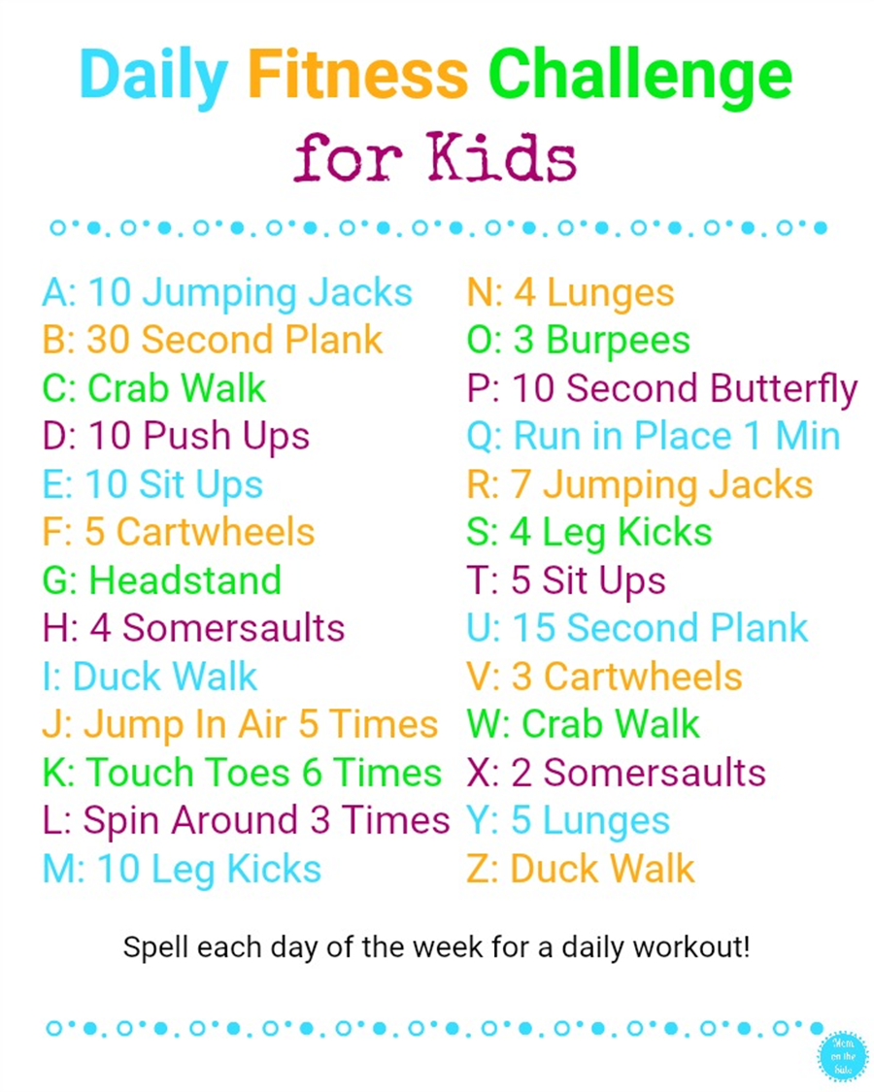

Yellowstone National Park
3-2-1
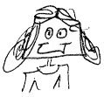
3 Things I learned

1.

2.

3.

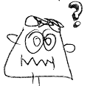
2 Questions I have

1.

2.

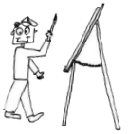
1 Picture

“Making Pickles”
(Deductive Thinking)
Bob, Bonnie, Connie, and Georgina are making pickles. Each one is in charge of either the cucumbers, the onions, the vinegar, or the sugar. One is peeling, one is slicing, one is measuring, and one is pouring. Their pickling tasks include scrubbing jars, sterilizing lids, stirring the brine, and screwing on the rings. Now see if you can unscramble this pickle.
Clues:
1. Connie scrubbed jars, while her brother peeled onions and her sister measured sugar.
2. Georgina poured her ingredient into a pot to boil while she stirred with a wooden spoon.
3. Bob was the strongest, so he screwed on the rings.
Bob | Bonnie | Connie | Georgina
cucumbers  onions  vinegar  sugar | cucumbers  onions  vinegar  sugar | cucumbers  onions  vinegar  sugar | cucumbers  onions  vinegar  sugar
peel  slice  measure  pour | peel  slice  measure  pour | peel  slice  measure  pour | peel  slice  measure  pour
scrub jars  sterilize lids  stir  screw on rings | scrub jars  sterilize lids  stir  screw on rings | scrub jars  sterilize lids  stir  screw on rings | scrub jars  sterilize lids  stir  screw on rings

Mystery Doug: WOW! Fact
- _____________________________________________
_____________________________________________________________________________________________________________________________________________

