Choice Board
Week of 3/30-4/3
Get Fit  “Roll for Fitness”  Task: Roll two dice and add the numbers together. The sum of the dice determines the exercise.  Suggestions:  - Only have 1 die, roll it twice!  - Ask a sibling/parent to “Roll for Fitness” with you! | Creative Thinking  Think outside the box by completing the “Creativity Challenge”.  Tell a Tale!  - What is “Tell a Tale”? This is a set of story starters that asks students to use their imagination to take the dramatic beginning and create their own story based on it! | Research  Learn about a topic that interests you through this week’s “Research Challenge”.  https://go.scholastic.com/go-tube-videos.html  Complete the 3-2-1 Graphic Organizer so show what you now know and what you’re still questioning!
The San Diego Zoo Virtual Field Trip  Visit http://messinatag.weebly.com/virtual-field-trips.html . Explore the San Diego Zoo. | Deductive Thinking Activity  The San Diego Zoo  Complete the thought-provoking puzzle about The San Diego Zoo. | STEM Connection  Read “The Daily STEM” Newsletter. Try the STEM Challenge and make a hypothesis for the Mystery Photo.
TAG Student Links
Explore the links on the TAG website. Try something new and have fun!
http://messinatag.weebly.com/

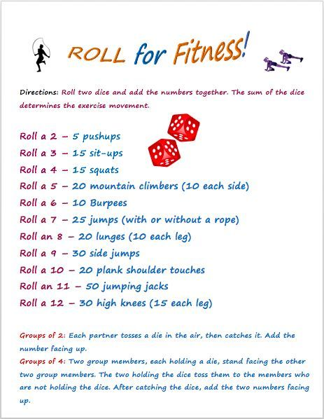
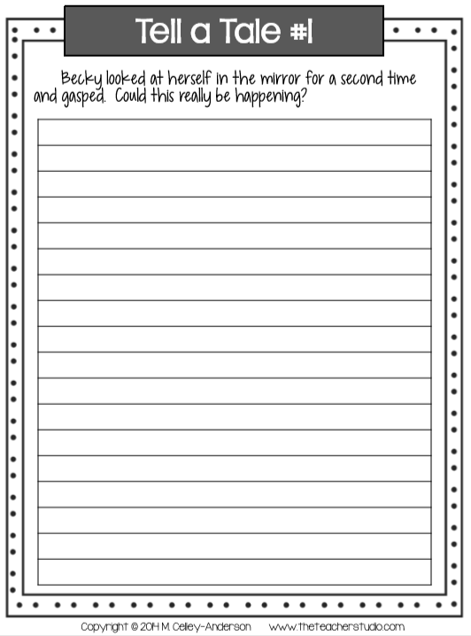
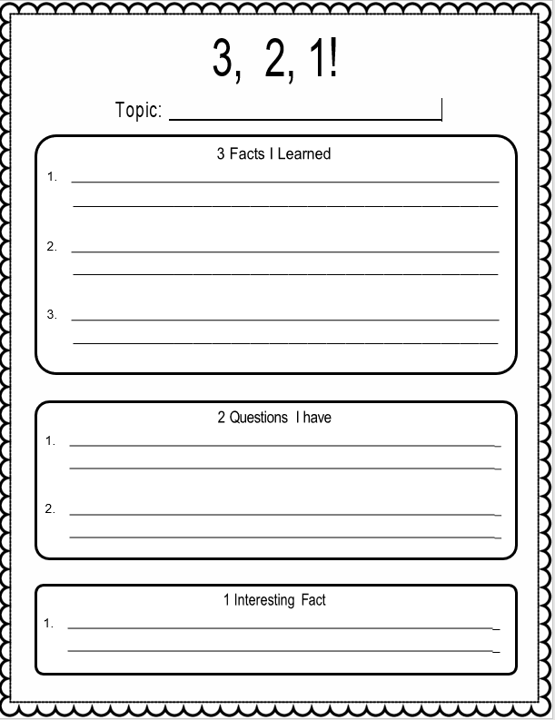

The San Diego Zoo
Mike, Cheryl, Summer, and Crystal Lane recently visited the San Diego Zoo where each found a favorite animal – penguins, elephants, rhinoceros, and leopards. The mother, father, and their two daughters enjoyed a snow cone, animal cookies, ice cream, and coffee while touring the zoo. Parade through the clues and try to snake out the solution to the puzzle.
Clues:
- The two sisters liked the penguins and rhinoceros.
- The person who thought the leopards were the most beautiful, enjoyed an ice cream cone.
- Father blew on his coffee to cool it.
- Crystal shared her animal cookies with her big sister.
- Summer asked for her father to buy her a cherry snow cone.
- The youngest person like the rhino.

 | father | mother | daughter | daughter | penguins | elephants | rhinoceros | leopards | snow cone | animal cookies | ice cream | coffee
Mike
Cheryl
Summer
Crystal
penguins
elephants
rhinoceros
leopard
snow cone
animal cookies
ice cream
coffee

