Choice Board
Week of 4/20-4/24
Virtual Farm Tour  While exploring the Canadian site FarmFood 360, you can go on tours of farms and learn about so many things from minks, pigs, and cows, to apples and eggs!  https://tinyurl.com/FarmFood-360  *Complete the 3-2-1 graphic organizer below to show what you learned on your trip to the farm* | Mystery Doug  Have you ever wondered how syrup is made? Visit Mystery Science to learn all about it!  https://tinyurl.com/MysteryDoug-Syrup  *What made you think WOW? Share 1 Wow! Fact about what you learned on how syrup is made* | STEM Connection  Read “The Daily STEM” Newsletter. Try “The Puzzle” and make a hypothesis for the Mystery Photo.  https://tinyurl.com/TheDailySTEM
TAG Student Links
Explore the links on the TAG website. Try something new and have fun!
http://messinatag.weebly.com/

Daily Fitness Challenge
*Check out the fitness challenge below! It’s always good to get up and move around! *

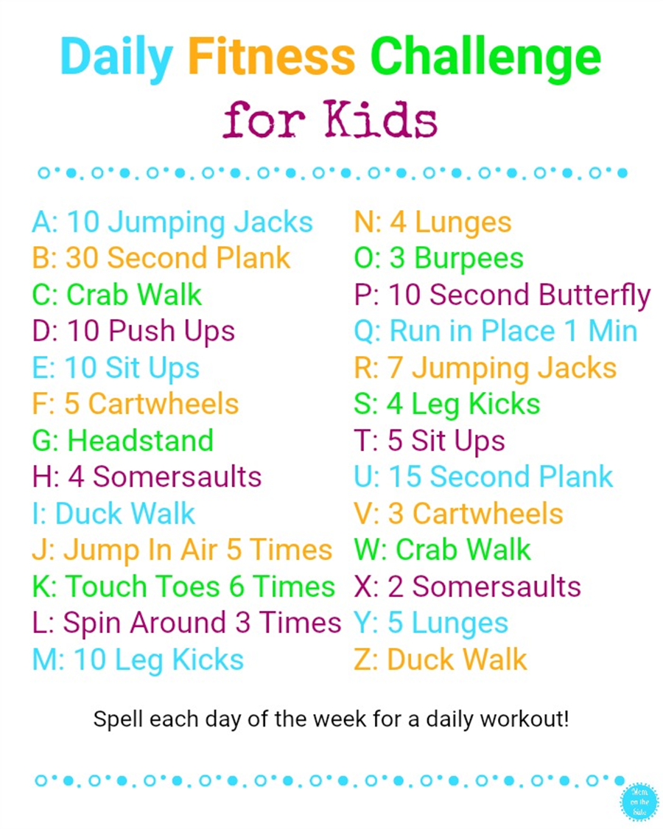

FarmFood 360
3-2-1
3 Things I learned

1.

2.

3.

2 Questions I have

1.

2.

1 Picture

