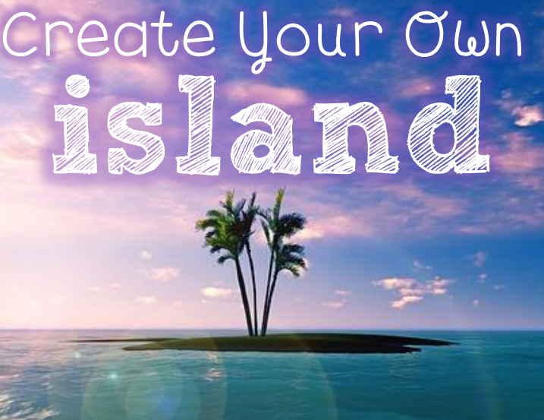
Credits: Created by Megan Joy

Create your own Island
Directions: Create your own island. Design a model to display with a sign that includes your name. Be creative!
Materials used:
___________________________________________________________________
___________________________________________________________________
___________________________________________________________________
___________________________________________________________________
___________________________________________________________________
___________________________________________________________________
___________________________________________________________________
___________________________________________________________________

Describe your island:

___________________________________________________________________
___________________________________________________________________
___________________________________________________________________
___________________________________________________________________
___________________________________________________________________
___________________________________________________________________
___________________________________________________________________
___________________________________________________________________
Create your own Island
- Island Name: __________________________________________________________

- Island Type: ___________________________________________________________

6 major kinds of islands – Below is a link to an excellent resource for additional information about the different kinds of islands.
https://www.eartheclipse.com/geography/types-of-islands.html
- Tidal
- Barrier
- Oceanic
- Coral
- Artificial

- Location: _____________________________________________________________

- Physical Features (mountains, lakes, rivers, etc.):
_____________________________________________________________________________
_____________________________________________________________________________
_____________________________________________________________________________
_____________________________________________________________________________
_____________________________________________________________________________
- Interesting Information:
_____________________________________________________________________________
_____________________________________________________________________________
_____________________________________________________________________________
_____________________________________________________________________________
_____________________________________________________________________________

