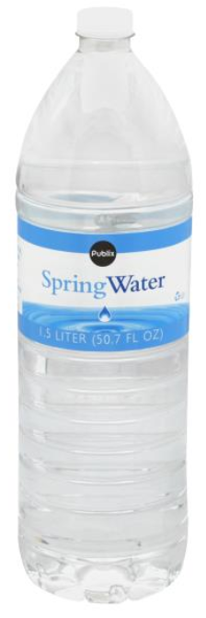
Georgia Coastal Lighthouse Materials

1) 1.5-liter water bottle
- The image shown works best for this project as it is the perfect size and the label comes off easiest.
2) Standard size flashlight (Dollar Store)

*If you are able to donate any of the below items, it will be greatly appreciated!
aluminum foil
black electrical tape
Play-doh (red, black, or white)

